Owl mentors – Revision 1.0

- -Remove white background of logo in the header + during buffering
- Header - Logo and Banner is not eye catching
- Remove browse a mentor button/link from the Header
- Owl mentors in black
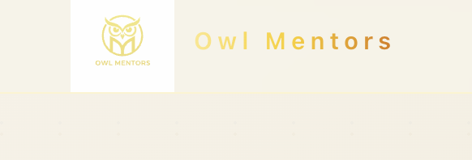

- - Remove the pre data and reviews from every place… no false data. Put any picture like preply.com
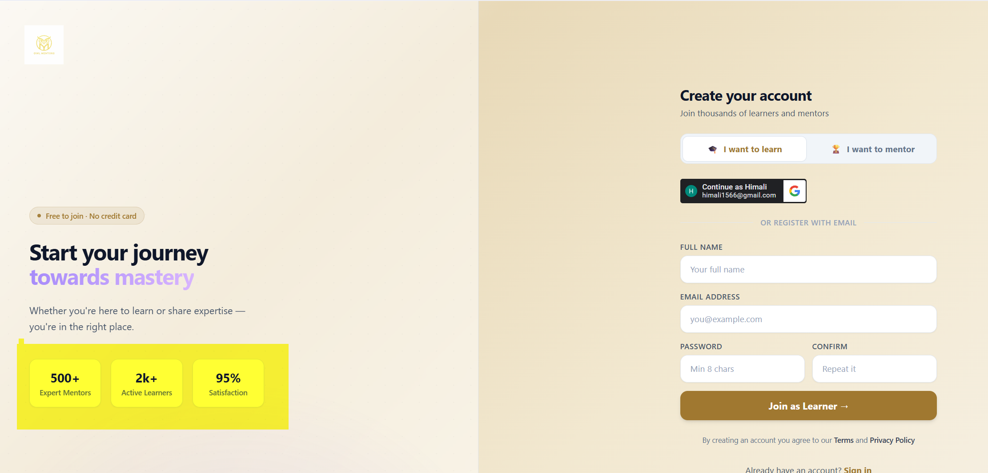

- - How It work Page – All caps title, white font not easy to read…also change the summary of how it works.
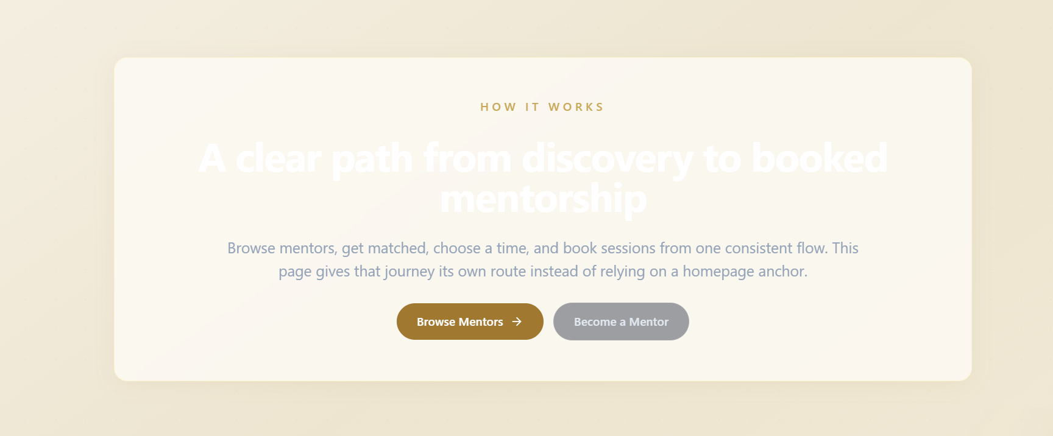

- -Some number appears on the find mentor page.

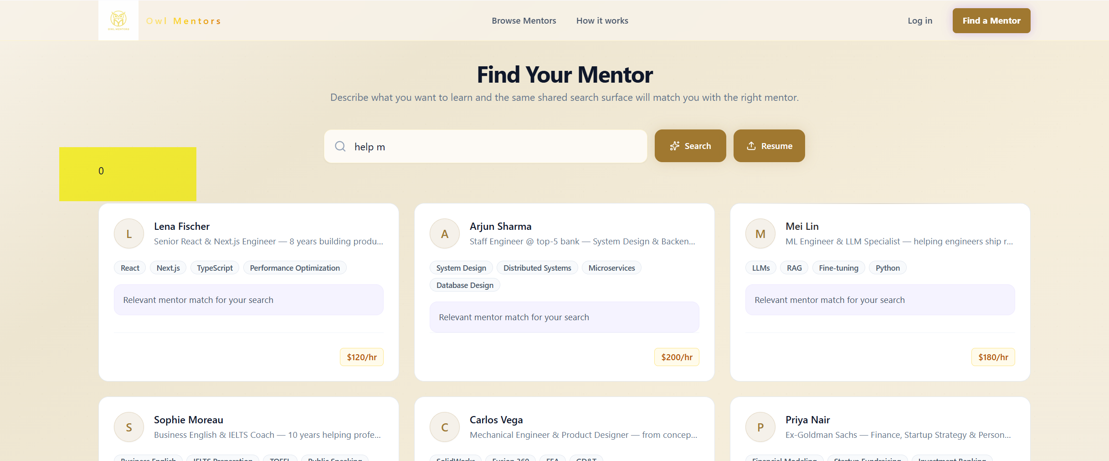

- Header having About Us , What we do, Find a mentor, Become a mentor + Only one Log in (remove signup)
About Us – Text – About Blu Codes and Owl Mentors as its app
What we do - You can generate through AI from the application
Find a mentor - https://www.owlmentors.com/browse
Become a mentor - https://www.owlmentors.com/register
AI career plan -after login
Login – Login for client, if they don’t have account, they can create a account from that page. Use google Gmail or apple ID or any email id to sign in. The login will have standard features as OTP, verification of email etc.
When you login browse mentor page should be displayed.
- User can edit his profile and delete his profile, You can keep scroll down below Blu Codes, even the logout button. Once login the site will allow to keep the user logged in, you can give checkbox as like no need to sign in for 30days.

- AI feature not working properly, please check. AI career plan should recommend career path courses
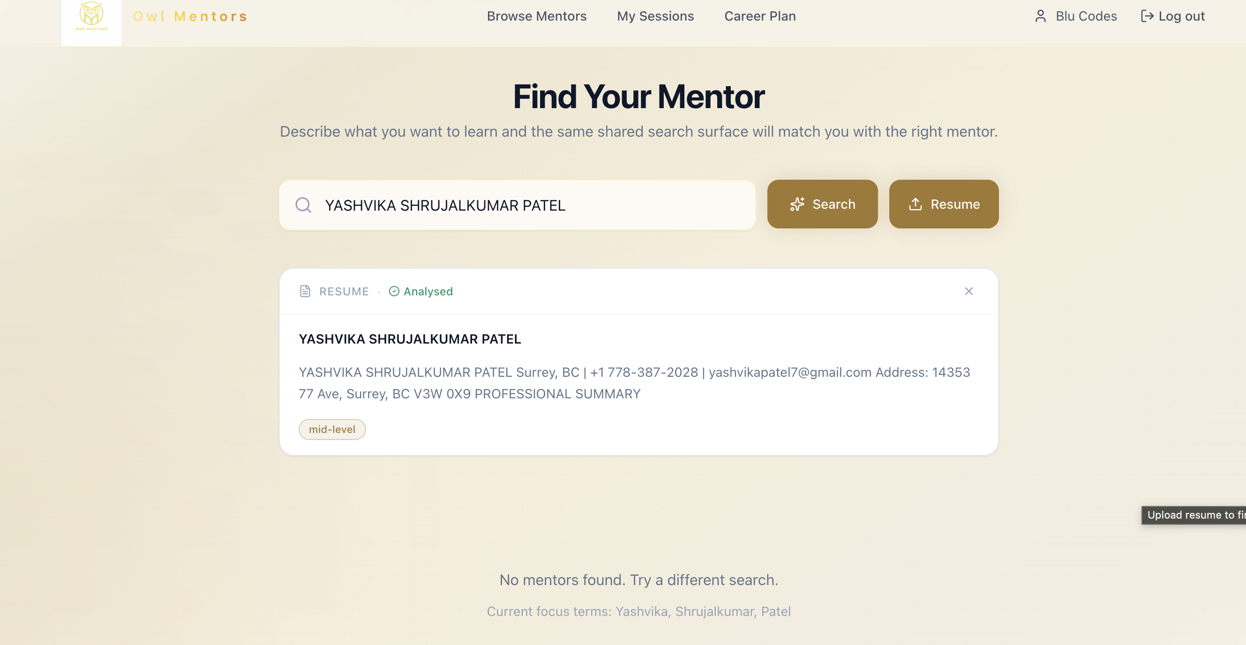

Sample (You can change the UI) I did AI in search
Based on your background, you already have experience in customer service, beauty services, retail operations, food service, delivery logistics, administration, and business studies (BBA). For 2026 and beyond, the strongest opportunities in Canada are roles that build on these skills while offering growth and better pay.

Recommended Career Paths for 2026–2030

1. Administrative & Office Coordinator (Most Practical Short-Term Path)
Why it fits:
- Your BBA studies align well.
- You already have experience with billing, scheduling, customer interactions, inventory, and Microsoft Office.
Entry Roles
- Administrative Assistant
- Office Assistant
- Receptionist
- Front Desk Coordinator
- Customer Support Representative
Growth Path
Administrative Assistant → Office Coordinator → Executive Assistant → Operations Coordinator → Office Manager
Courses
- Microsoft Excel (Intermediate & Advanced)
- Business Communication
- Administrative Professional Certificate
- Data Entry & Records Management
- Customer Relationship Management (CRM) Software
Useful software to learn:
- Microsoft Excel
- Microsoft Outlook
- Salesforce
- QuickBooks

2. Beauty Industry Management (High Potential Given Your Experience)
You already have 5 years of salon-related experience.
Entry Roles
- Salon Coordinator
- Beauty Advisor
- Spa Receptionist
- Esthetician Assistant
- Salon Manager Trainee
Growth Path
Beauty Advisor → Senior Esthetician → Salon Manager → Regional Manager → Business Owner
Courses
- Medical Esthetics
- Advanced Skin Care
- Laser Technician Certification
- Spa Management
- Beauty Business Management
This path can become especially profitable if you eventually open your own salon or beauty business.

3. Customer Success & Client Services
Many Canadian companies hire people with strong communication and customer-handling skills.
Entry Roles
- Customer Service Representative
- Client Services Associate
- Customer Support Specialist
- Call Centre Representative
Growth Path
Customer Service Representative → Customer Success Specialist → Team Lead → Customer Success Manager
Courses
- Customer Experience (CX)
- Conflict Resolution
- Professional Communication
- CRM Platforms
Learn:
- Zendesk
- HubSpot
- Salesforce

4. Human Resources (Excellent Match with BBA)
This is one of the strongest office careers for business students.
Entry Roles
- HR Assistant
- Recruitment Coordinator
- Talent Acquisition Assistant
Growth Path
HR Assistant → HR Coordinator → HR Generalist → HR Manager
Courses
- HR Fundamentals
- Recruitment & Talent Acquisition
- Employment Law Basics
- Payroll Administration
Consider pursuing:
- CPHR Canada pathways later in your career.

5. Supply Chain & Logistics (Growing Field)
Your delivery and inventory experience provides a foundation.
Entry Roles
- Logistics Coordinator
- Dispatch Coordinator
- Inventory Clerk
- Warehouse Administrator
Growth Path
Logistics Coordinator → Supply Chain Analyst → Operations Manager
Courses
- Supply Chain Management
- Logistics & Transportation
- Inventory Management
- Excel for Data Analysis

6. Digital Marketing (Modern Career Option)
You have previous marketing experience from Shruti Collection.
Entry Roles
- Marketing Assistant
- Social Media Coordinator
- Content Coordinator
Growth Path
Marketing Assistant → Digital Marketing Specialist → Marketing Manager
Courses
- Digital Marketing Fundamentals
- Search Engine Optimization (SEO)
- Social Media Marketing
- Content Marketing
- Analytics
Learn:
- Google Analytics
- Canva

Best Certifications to Complete in 2026
If your goal is a stable job while studying BBA, prioritize:
- Microsoft Excel Advanced
- QuickBooks Certification
- Customer Service Certificate
- HR Fundamentals Certificate
- Digital Marketing Certificate
- First Aid & CPR Certification
- Food Safe Level 1 (useful for hospitality jobs)
Then our platform will suggest mentor based on keywords that are suggested. In that way the client get problem and solution both at one place. If you want we can create something which she can select and then can refine. This was a fresher sample resume, I believe for experience it will be better. If you can capture some sort of keywords that client is looking for in admin then I can search such mentors.

- -Keep mentors’ picture large in the below
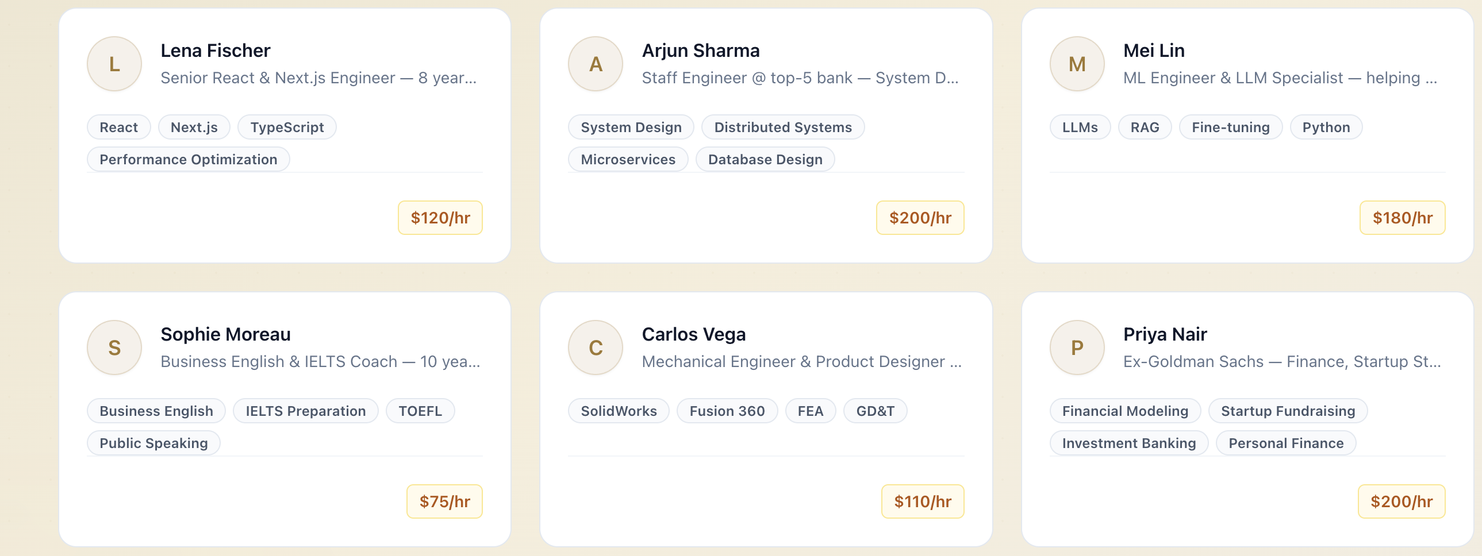

- Book a session – pops up or new page.
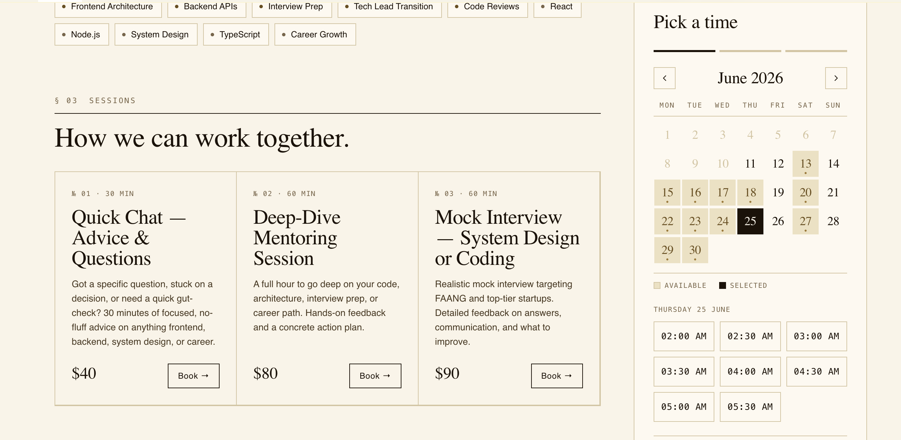

- Remove – not required, it will be shown automatically in the calendar when booking a session
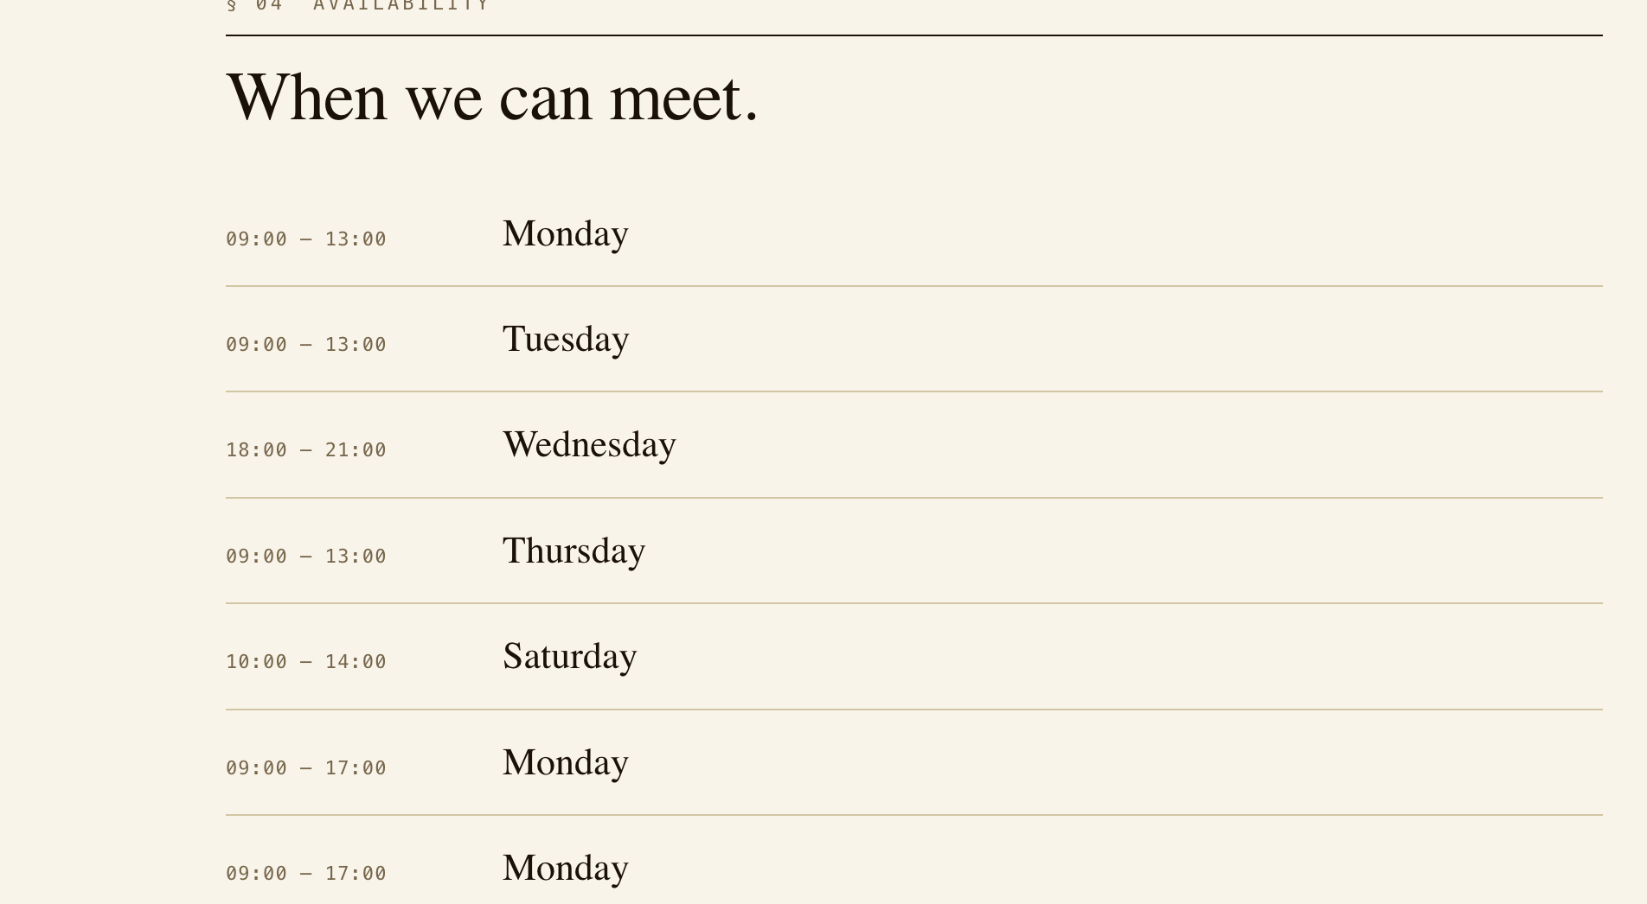

- Reschedule allow 4 hrs before and cancellation allowed 24hrs before else no refund or reschedule. Else no option available and display a message- like not possible. Client can reschedule once only

- I need some reminder in email before 1 day by email and 30 mins before the session and if possible, add the meeting link - https://www.owlmentors.com/video/6a2a338df121a642755ef7ed

- The email needs more details and correct the spelling Owl Mentors in all the files
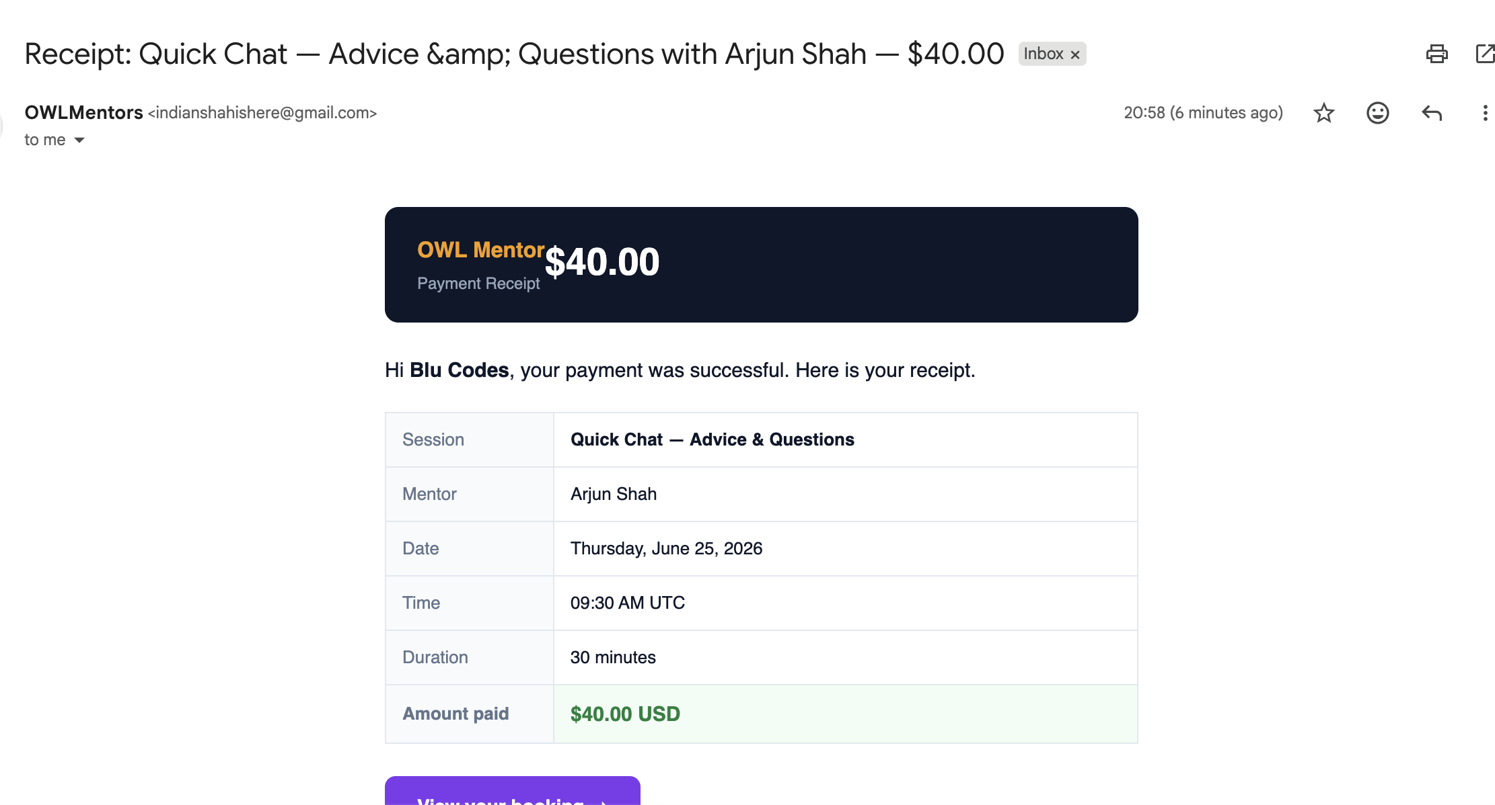

- Remove Side Bar Completely.
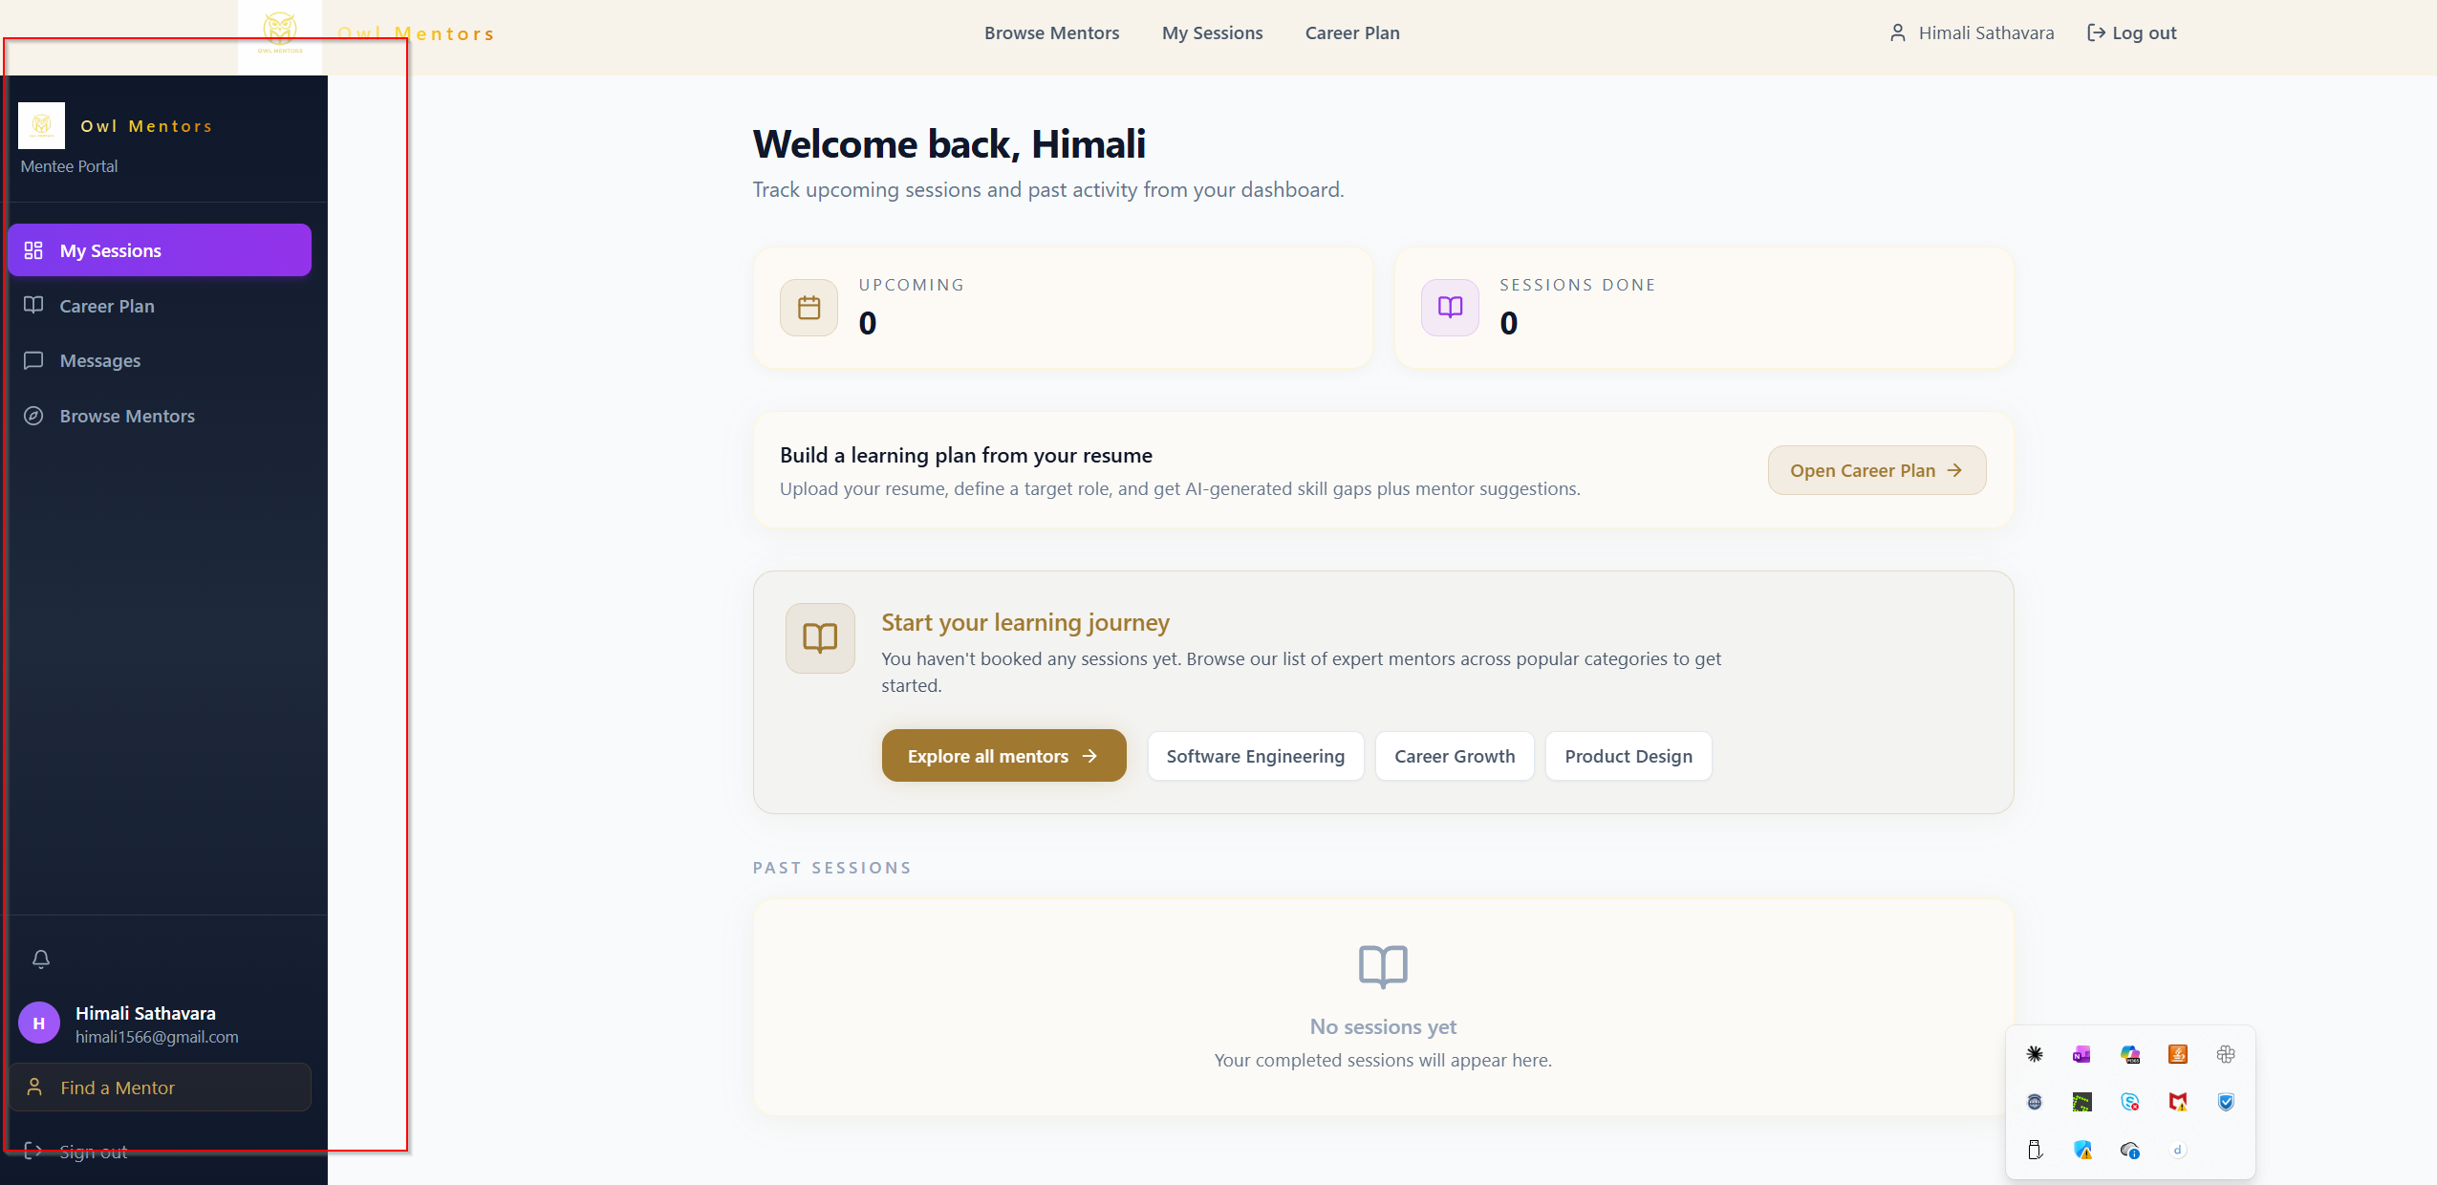

- Error in Messages, My Session Message both Menus stays selected

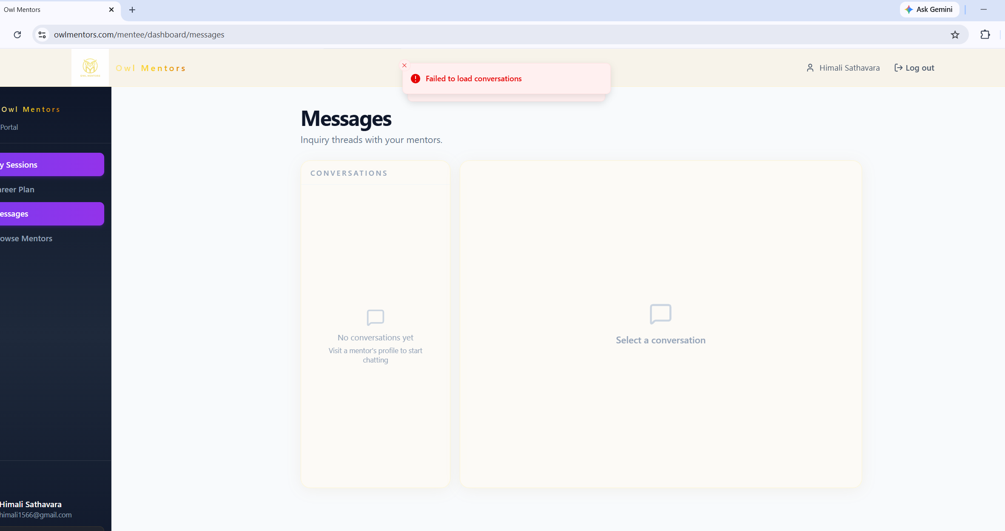

- When Mentors are searches small section appears , remove below section its same for all mentors in search result or display summary of mentor’s work.
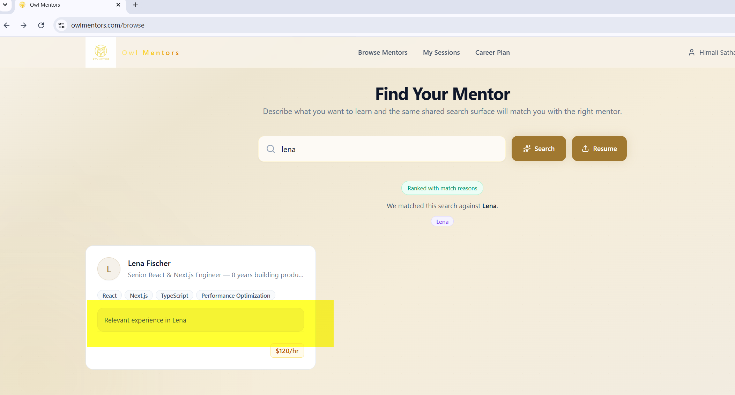
- Remove this from the search results. It appears for any search

- - Remove the pre data and reviews from every place… no false data.

- - How It work Page – All caps title, white font not easy to read.. also change the summary of how it works.


- - Login Button- Same login page as a current Find a Mentor button login page

- No Payment received after the booking .. Receipt of the booking and the meeting link should be different emails.

- On View Booking from the email different page “Owlmentor.com” is open. It should be “owlmentors.com”
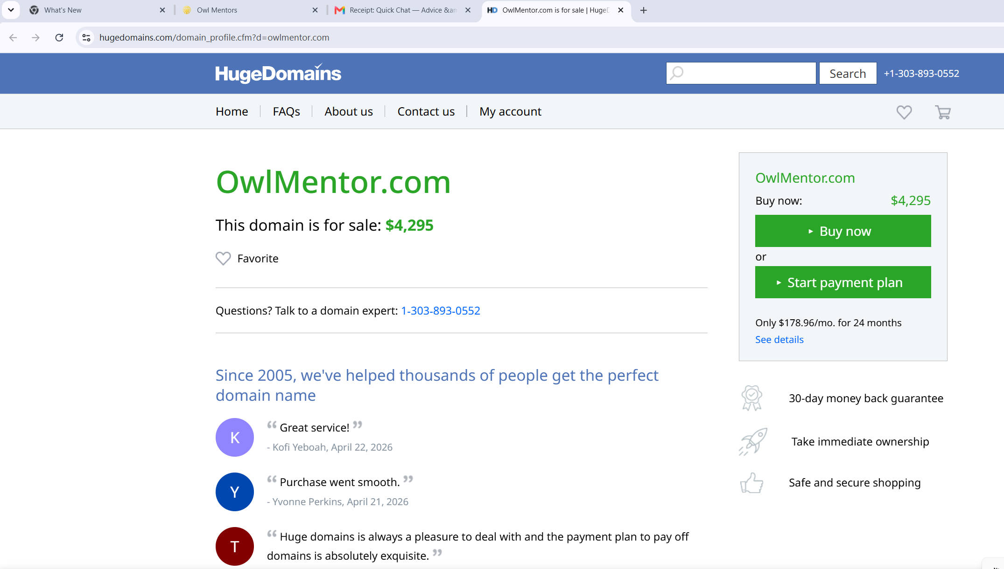

Sign Up Page
- Remove all Uppercase labels
- Keep Labels Password and Confirm Password
- In the Confirm Password field change the place holder from “repeat it” to “confirm password”
- Strong Password validation

- Remove last login details – can’t change it to different user.
